Setting Up a DerbyNet Server on a Mac

MacOS 12 (Monterey) users, please note:
The instructions below will not work for macOS 12 (Monterey). Please see the “MacOS 12 (Monterey)” section, below, before attempting to install DerbyNet.
The DerbyNet installer for Macintosh takes care of installing the DerbyNet server software, as well as the MacReplay application and the derby-timer.jar timer interface.
Mac OS X includes security features that intentionally make it difficult to install software that's downloaded from the internet. Launching the DerbyNet installer for Macintosh may require using the special procedure described below.
DerbyNet depends on a web server platform, with a PHP implementation and with access to a database. Mac OS X includes these software elements, but they are deactivated by default. The DerbyNet installer for Macintosh activates these elements for you, but the following limitations apply:
- The web server will have to be restarted whenever the Macintosh restarts.
- The web server will probably have to be reconfigured after each upgrade of Mac OS X.
These concerns are addressed below.

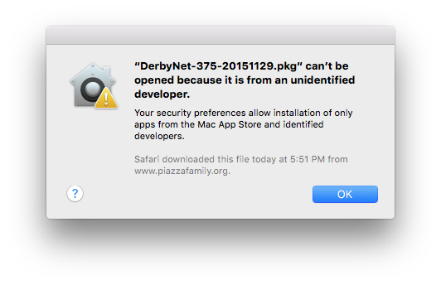
Launching the Installer
If launching the DerbyNet installer for Macintosh produces an error message to the effect that the software is from an “unidentified developer,” you need to follow the simple but non-obvious procedure described here:
https://support.apple.com/kb/ph18657?locale=en_US
After installation, the DerbyNet home page will be available at http://localhost/derbynet. If you don’t already have a web site configured, then just visiting http://localhost should redirect your browser to http://localhost/derbynet.

About Passwords
The installer establishes two roles and passwords by default. For details, including how to recover and change the passwords, see the “Default Roles and Passwords” document that accompanies this installation guide in the /Applications/DerbyNet/docs folder.

Restarting the Apache Web Server
The DerbyNet installer for Macintosh starts the built-in Apache web server, but it will be necessary to restart it whenever the computer is rebooted. The Apache web server can be restarted from the command line (the “Terminal” application). The command to start the web server is:
sudo apachectl start
(Expect to be prompted for your password.)
The command to stop the server is:
sudo apachectl stop

After a Mac OS X Upgrade
The DerbyNet installer for Macintosh includes a postinstall script that performs configuration changes necessary to activate PHP and database drivers for the built-in Apache web server. An upgrade to Mac OS X will usually overwrite these configuration files, losing the effect of the DerbyNet installer's postinstall script.
After an upgrade to Mac OS X, you should either:
- Re-install DerbyNet, or
- Re-execute the update-apache-config.sh script, found in the /Applications/DerbyNet folder.

MacOS 12 (Monterey)
As mentioned above, macOS 12 (Monterey) omits support for PHP applications like DerbyNet. The installation process described above will not succeed if PHP is not installed.

Installing PHP Yourself
It’s possible to install PHP yourself, using HomeBrew (https://brew.sh), and then proceed as with earlier versions of macOS. This involves some manual steps in order to sign the installed PHP module. The steps aren’t terribly involved, but it’s not completely turnkey, and is beyond the scope of this document. See, for example, https://wpbeaches.com/updating-to-php-versions-7-4-and-8-on-macos-12-monterey/ and https://www.simplified.guide/macos/apache-php-homebrew-codesign. If you pursue this route, PHP 7.4 is recommended.

Using Docker
A better alternative is probably to deploy DerbyNet in a docker container. The companion “Installation- Docker” document describes using a docker container to run DerbyNet.

